# CS 255 System Design Document Template

This template lays out all the different sections that you need to complete for Project Two. Each section has guidance to prompt your thinking. You will need to continually reference the interview transcript as you work to make sure that you are addressing your client’s needs. There is no required length for the final document. Instead the goal is to complete each section based on what your client’s needs are. Remove this note when you are finished, and replace all bracketed text with the relevant information.

## UML Diagrams

### UML Use Case Diagram

*[In Module Six, you were asked to complete a use case diagram based on your system design. If you would like to make any adjustments to your diagram, please do so. Please insert your use case diagram here. Check to make sure that you included appropriate components and symbols and that your design meets the client’s needs.]*

**

### UML Activity Diagrams

*[You were asked to choose* ***two*** *use cases and create* ***two*** *activity diagrams, one for each use case. Please insert* ***both*** *of your activity diagrams here. Check to make sure that you included appropriate components and symbols and that your design meets the client’s needs.]*

### UML Sequence Diagram

*[You were asked to create a sequence diagram based on* ***one*** *of the use cases you chose. Please insert your sequence diagram here. Check to make sure that you included appropriate components and symbols and that your design meets the client’s needs.]*

### UML Class Diagram

*[You were asked to create a class diagram based on the different classes and attributes needed for your system design. You are* ***not*** *required to include methods, but you may if you wish. Please insert your class diagram here. Check to make sure that you included appropriate components and symbols and that your design meets the client’s requirements.]*

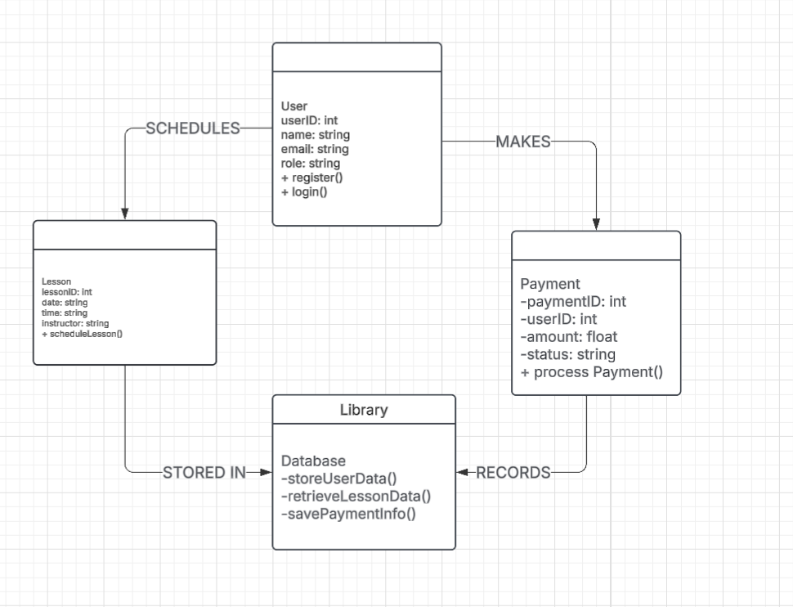

## Technical Requirements

*[Based on the diagrams you have created, describe the technical requirements of your system. These requirements should address the required hardware, software, tools, and infrastructure necessary for your system design.]*

*1. Hardware Requirements*

*Web Server: Minimum 8GB RAM, 100GB storage, multi-core processor.*

*Client Devices: System must be accessible on desktops, laptops, tablets, and smartphones.*

*Database Server: Requires scalable storage to support growing student records and lesson schedules.*

*2. Software Requirements*

*Operating System: Cloud-based deployment with compatibility for Windows, macOS, and Linux servers.*

*Web Framework: Development using Django (Python) or Spring Boot (Java).*

*Database Management System: MySQL or PostgreSQL for secure data storage.*

*Testing Framework: JUnit (for backend testing), Selenium (for UI automation testing).*

*3. Infrastructure & Security*

*Hosting: Cloud-based hosting (AWS, Azure, or Google Cloud) for scalability and uptime reliability.*

*Security Measures:*

*Encryption: All data transmission must be secured using TLS/SSL encryption.*

*Authentication: Role-based access control (RBAC) with multi-factor authentication (MFA) for sensitive actions.*

*Database Security: Regular backups and encryption for sensitive data (user credentials, payment info).*

*Payment Processing: Integration with Stripe or PayPal for secure transactions.*

*System Monitoring: Automated alerts for failed logins, unauthorized access, and system errors.*